**Topics: Descriptive Statistics and Probability**

1. Look at the data given below. Plot the data, find the outliers and find out $μ, σ, σ^{2}$

|  |  |
| --- | --- |
| **Name of company** | **Measure X** |
| Allied Signal | 24.23% |
| Bankers Trust | 25.53% |
| General Mills | 25.41% |
| ITT Industries | 24.14% |
| J.P. Morgan & Co. | 29.62% |
| Lehman Brothers | 28.25% |
| Marriott | 25.81% |
| MCI | 24.39% |
| Merrill Lynch | 40.26% |
| Microsoft | 32.95% |
| Morgan Stanley | 91.36% |
| Sun Microsystems | 25.99% |
| Travelers | 39.42% |
| US Airways | 26.71% |
| Warner-Lambert | 35.00% |

$μ$ = 33.2713, $σ$ = 16.9453, $σ^{2}$ = 287.1466, Outlier is Morgan Stanley = 91.36%.

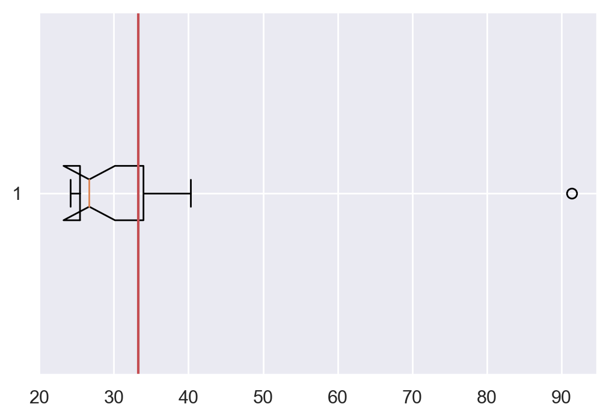



Answer the following three questions based on the box-plot above.

1. What is inter-quartile range of this dataset? (Please approximate the numbers) In one line, explain what this value implies.

* IQR = 12 – 5 = 7. IQR contains 50% of data used to plot boxplot.

1. What can we say about the skewness of this dataset?

* From boxplot we can see data below median is concentrated on **left** of boxplot. So, we can say that data is **‘skewed right’**.

1. If it was found that the data point with the value 25 is actually 2.5, how would the new box-plot be affected?

* If value 25 is actually 2.5 then the boxplot **will not** have any outlier and will have less slight change in **skewness value**, might even be considered as **normally distributed**. ‘**Median**’ will also be slightly shifted to right.



Answer the following three questions based on the histogram above.

1. Where would the mode of this dataset lie?

* Mode of dataset lies at values **5** and **7**.

1. Comment on the skewness of the dataset.

* From histogram, we can see that data is mostly concentrated on left-side of plot as well as we have an outlier on right-side of plot. So, we can say that dataset is **skewed right** .

1. Suppose that the above histogram and the box-plot in question 2 are plotted for the same dataset. Explain how these graphs complement each other in providing information about any dataset.

* Boxplot shows us **median** as well as **distribution** of data is situated in given range. Whereas histogram gives us the frequency with which data occurs and why we have **median** toward **left** despite having such wide range.

1. AT&T was running commercials in 1990 aimed at luring back customers who had switched to one of the other long-distance phone service providers. One such commercial shows a businessman trying to reach Phoenix and mistakenly getting Fiji, where a half-naked native on a beach responds incomprehensibly in Polynesian. When asked about this advertisement, AT&T admitted that the portrayed incident did not actually take place but added that this was an enactment of something that “could happen.” Suppose that one in 200 long-distance telephone calls is misdirected. What is the probability that at least one in five attempted telephone calls reaches the wrong number? (Assume independence of attempts.)

* Probability that call is misdirected = **1/200**

Probability that call is not misdirected = 1-(1/200) = **199/200**

For probability that at least one in five attempted telephone calls reaches the wrong number, we use binomial distribution formula.

**P(x) = nCx .px(1 − p) n−x, n = 5 and x = 1**

P(x) = 5C1.P5(1 − p)5−1 = (5! / 4!1!) * (1/200)1 * (199/200)4

P(x) = (5 * 1994) / 2005

**P(x) = 0.0245**

1. Returns on a certain business venture, to the nearest $1,000, are known to follow the following probability distribution

|  |  |
| --- | --- |
| x | P(x) |
| -2,000 | 0.1 |
| -1,000 | 0.1 |
| 0 | 0.2 |
| 1000 | 0.2 |
| 2000 | 0.3 |
| 3000 | 0.1 |

1. What is the most likely monetary outcome of the business venture?

* **2000**

1. Is the venture likely to be successful? Explain

* **Yes**, as probability of making profit is higher than probability of having loss.

1. What is the long-term average earning of business ventures of this kind? Explain

* Long-term average earning of business ventures is equal to **expected** **value** of probability function. Expected value is given as,

$E\left(x\right)=∑x⋅P\left(x\right)$ = (-2000 * 0.1) + (-1000 * 0.1) + (0 * 0.2) + (1000 * 0.2) + (2000 * 0.3) + (3000 * 0.1) = **800** .

1. What is the good measure of the risk involved in a venture of this kind? Compute this measure

* Good measure of the risk involved is,

P(Loss) = P(-2000) + P(-1000) = 0.1 + 0.1 = **0.2** **=** **20%** .